ZIP
=====

Create a ZIP Archive
=======================
#touch file{1..5}.txt

zip files file1.txt file2.txt file3.txt file4.txt file5.txt
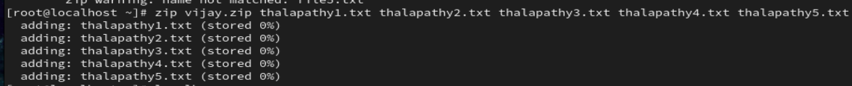
List ZIP File Contents
=========================
zip -sf files.zip
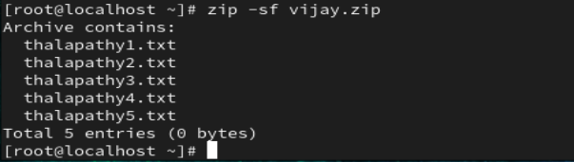

Add Specific File Types to ZIP Archive
=========================================
zip files *.txt
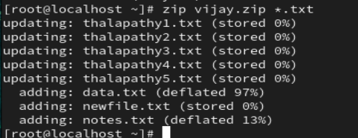

Add a Directory to ZIP Archive
==================================
zip -r files <directory>
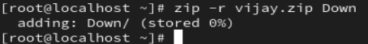

Delete Files From ZIP Archive
=================================
zip -sf <archive file>
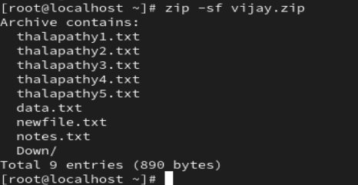
zip -d <archive file> <files for deletion>
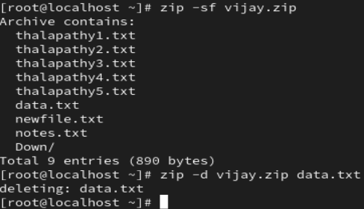
zip -d files.zip file5.txt
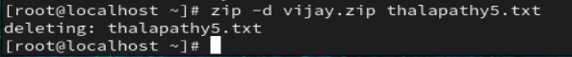
fallocate -l 1G testfile

zip test.zip testfile
ls -lh

unzip test.zip
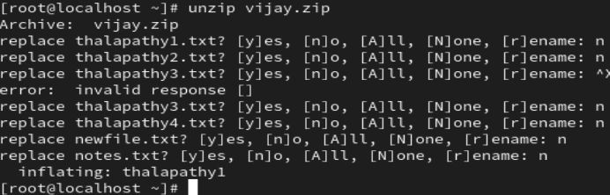
ls -lh
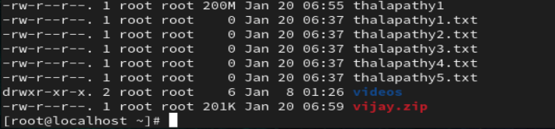

GZIP
=====

Compressing Files
=====================

gzip filename

Compress multiple files
gzip file1 file2 file3 file4
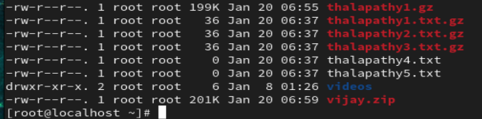

Keep the original file
========================
gzip -k filename
Verbose output
=================
gzip -v filename
Compress all files in a directory
==================================

gzip -r directory

Decompressing Files
========================

gzip -d filename.gz

gunzip filename.gz

Decompress multiple files
===============================
gzip -d file1.gz file2.gz file3.gz

Decompress all files in a directory
========================================
gzip -dr directory

Keep the compressed file
=============================
gzip -dk filename.gz
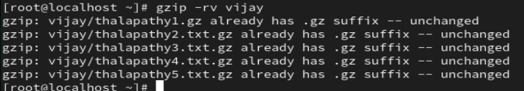

List the Compressed File Contents
=====================================

gzip -lv filename

TAR
=======

1. Create a tar Archive File in Linux

tar -cvf etc-backup-14-09-12.tar /etc
c – Creates a new .tar archive file.
v – Verbosely show the .tar file progress.
f – File name type of the archive file.

2. Create tar.gz Archive File in Linux (Note: tar.gz and tgz both are similar).
============================================

4. Untar tar Archive File in Linux (tar,tar.gz,tar.bz2)
=====================================

Untar files in Current Directory
tar -xvf etc-backup.tar

tar -xvf etc-backup.tar -C /mnt
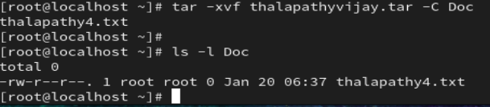

Untar Single file from tar File in Linux
=============================================

Single file
tar -xvf etc-backup.tar passwd group


List Content of tar Archive File in Linux
============================================

tar -tvf backup.tar
Add Files or Directories to tar Archive File in Linux
=========================================================

tar -rvf backup.tar file1 file2

Remove File and Directory from Tar Archive
============================================

tar --delete -f backup.tar.gz file1.txt
